**Hive Assignment**

1. Download Vehicle sales data from ----> <https://github.com/shashank-mishra219/Hive-Class/blob/main/sales_order_data.csv>
2. Store raw data into hdfs location:

**hadoop fs -put sales_order_data.csv /tmp/hive/**

1. Create a internal hive table "sales_order_csv" which will store csv data sales_order_csv .. make sure to skip header row while creating table

**create table sales_order_csv**

**(**

**ORDERNUMBER int,**

**QUANTITYORDERED int,**

**PRICEEACH float,**

**ORDERLINENUMBER int,**

**SALES float,**

**STATUS string,**

**QTR_ID int,**

**MONTH_ID int,**

**YEAR_ID int,**

**PRODUCTLINE string,**

**MSRP int,**

**PRODUCTCODE string,**

**PHONE string,**

**CITY string,**

**STATE string,**

**POSTALCODE string,**

**COUNTRY string,**

**TERRITORY string,**

**CONTACTLASTNAME string,**

**CONTACTFIRSTNAME string,**

**DEALSIZE string**

**)**

**row format delimited**

**fields terminated by ','**

**tblproperties("skip.header.line.count"="1")**

**;**

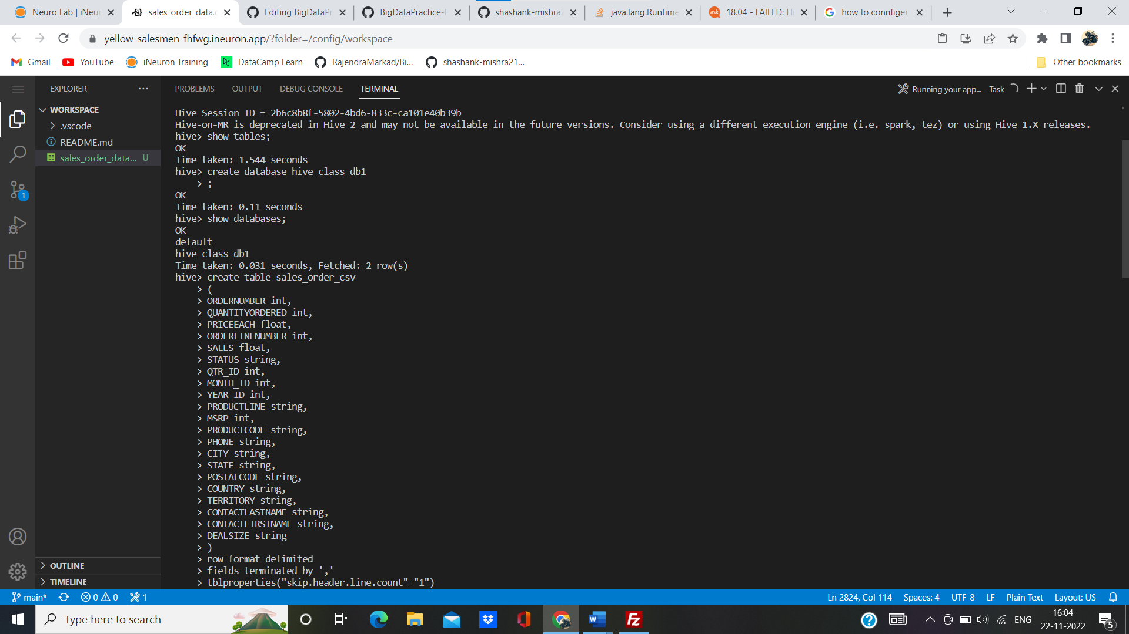

1. Load data from hdfs path into "sales_order_csv"

**hive> load data inpath '/tmp/hive/sales_order_data.csv' into table sales_order_csv;**

**Hive> set hive.cli.print.header = true;**

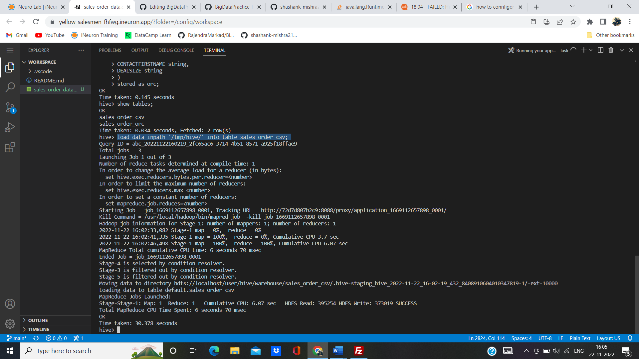

1. Create an internal hive table which will store data in ORC format "sales_order_orc"

**hive> create table sales_order_orc**

**> (**

**> ORDERNUMBER int,**

**> QUANTITYORDERED int,**

**> PRICEEACH float,**

**> ORDERLINENUMBER int,**

**> SALES float,**

**> STATUS string,**

**> QTR_ID int,**

**> MONTH_ID int,**

**> YEAR_ID int,**

**> PRODUCTLINE string,**

**> MSRP int,**

**> PRODUCTCODE string,**

**> PHONE string,**

**> CITY string,**

**> STATE string,**

**> POSTALCODE string,**

**> COUNTRY string,**

**> TERRITORY string,**

**> CONTACTLASTNAME string,**

**> CONTACTFIRSTNAME string,**

**> DEALSIZE string**

**> )**

**> stored as orc;**

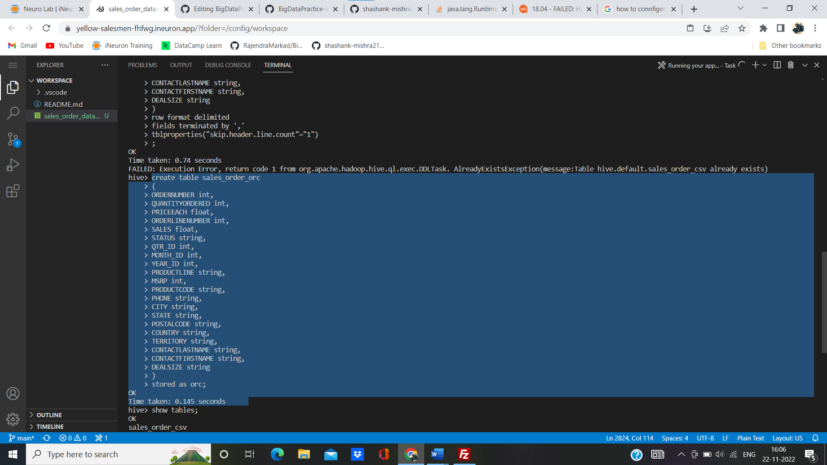

1. Load data from "sales_order_csv" into "sales_order_orc"

**Hive> insert overwrite table sales_order_orc select * from sales_order_csv;**

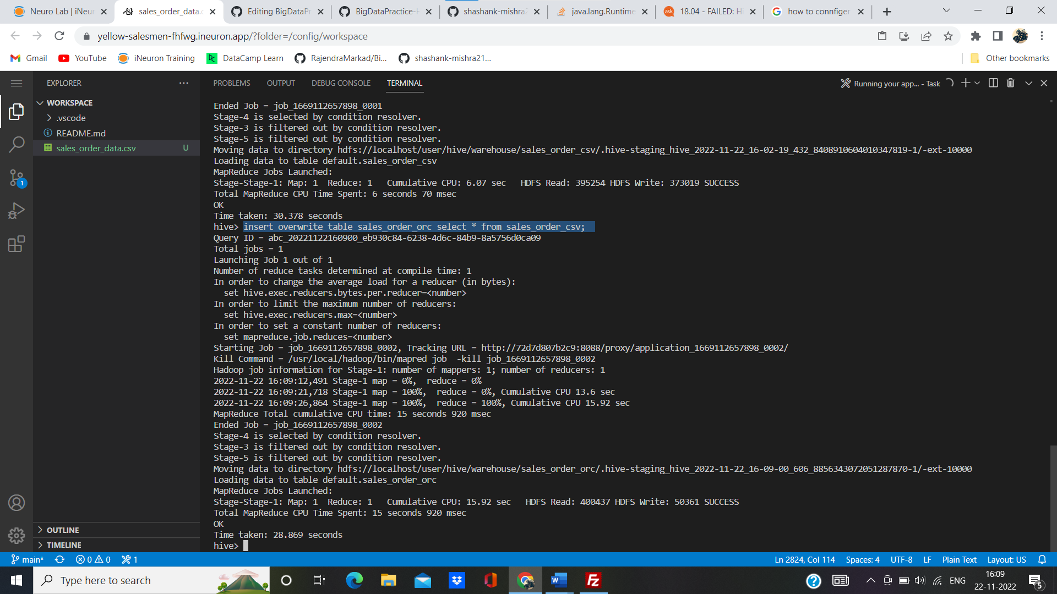

7. Perform below mentioned queries on "**sales_order_orc**" table :

a. Calculate the total sales per year

**hive> select year_id as year, sum(sales) as total_sales from sales_order_orc group by year_id ;**

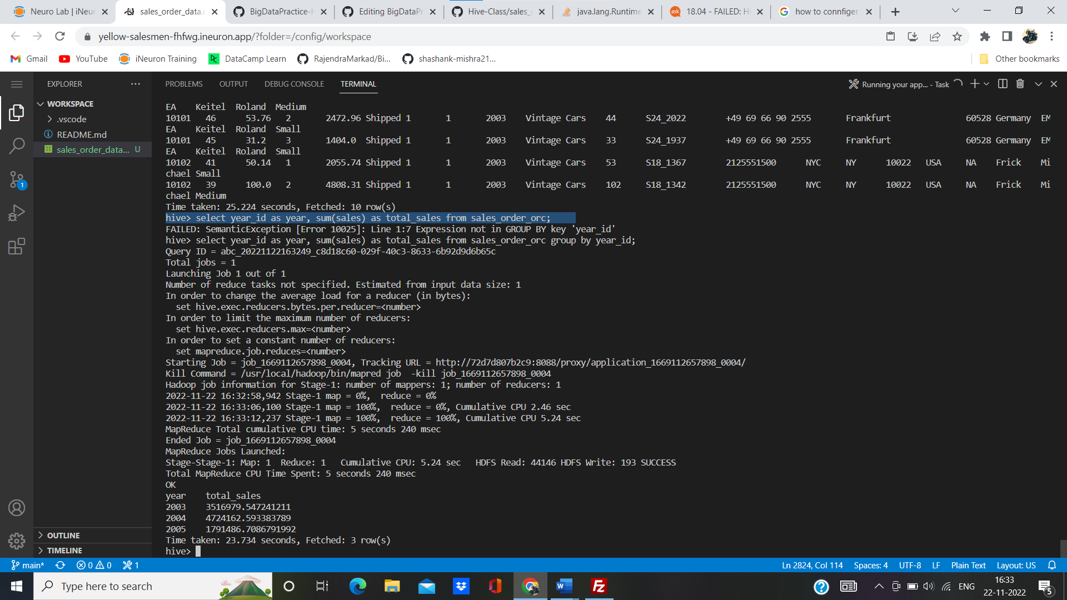

b. Find a product for which maximum orders were placed

hive>**Select A.productline from (Select sum(quantityordered) as maxquantity, productline from sales_order_orc group by productline order by maxquantity desc limit 1) A;**

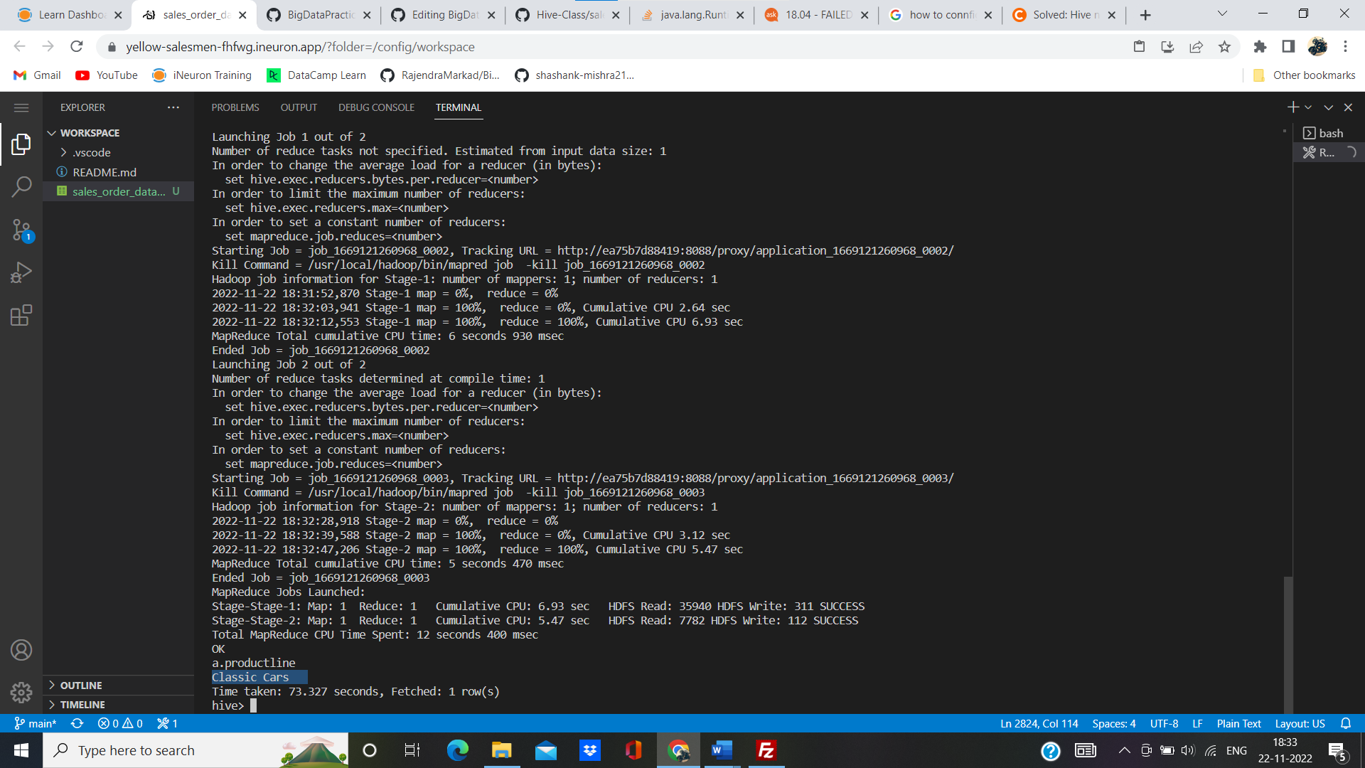

c. Calculate the total sales for each quarter

**Select sum(sales), qtr_id from sales_order_orc group by qtr_id;**

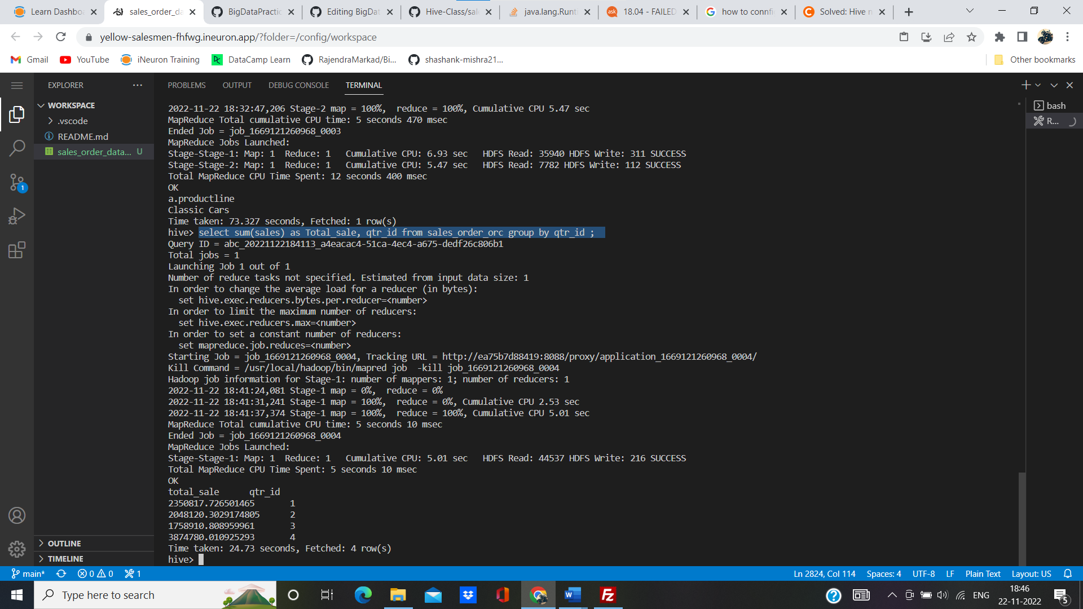

d. In which quarter sales was minimum?

**hive> select sum(sales) as min_sale, qtr_id from sales_order_orc group by qtr_id order by min_sale limit 1;**

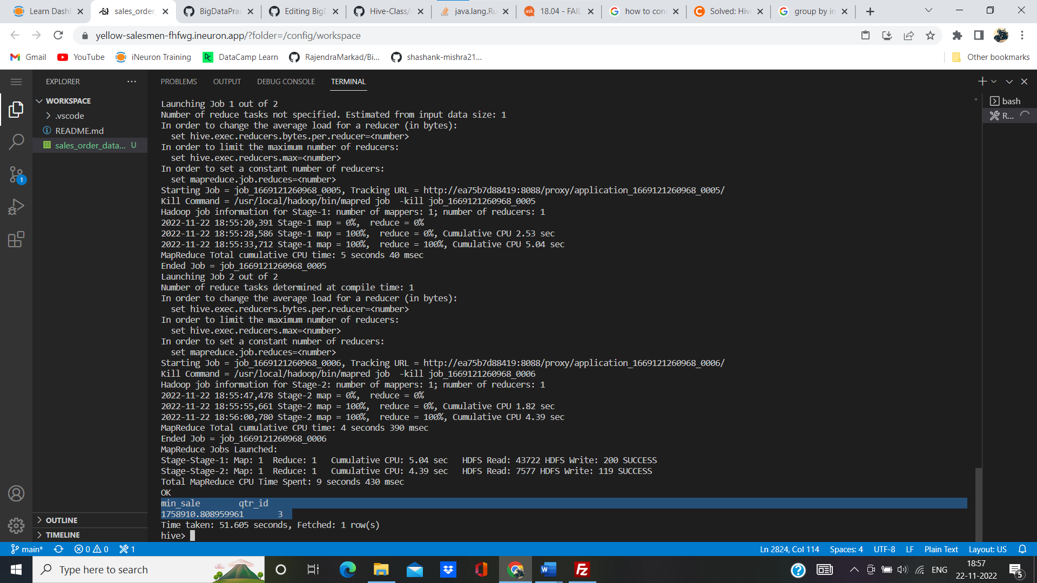

e. In which country sales was maximum and in which country sales was minimum

**Hive> select A.country, A.sales from (select country, sales, rank() over (order by sales) min_rank, rank() over(order by sales desc) max_rank from sales_order_orc)A where min_rank = 1 or max_rank =1 order by sales;**

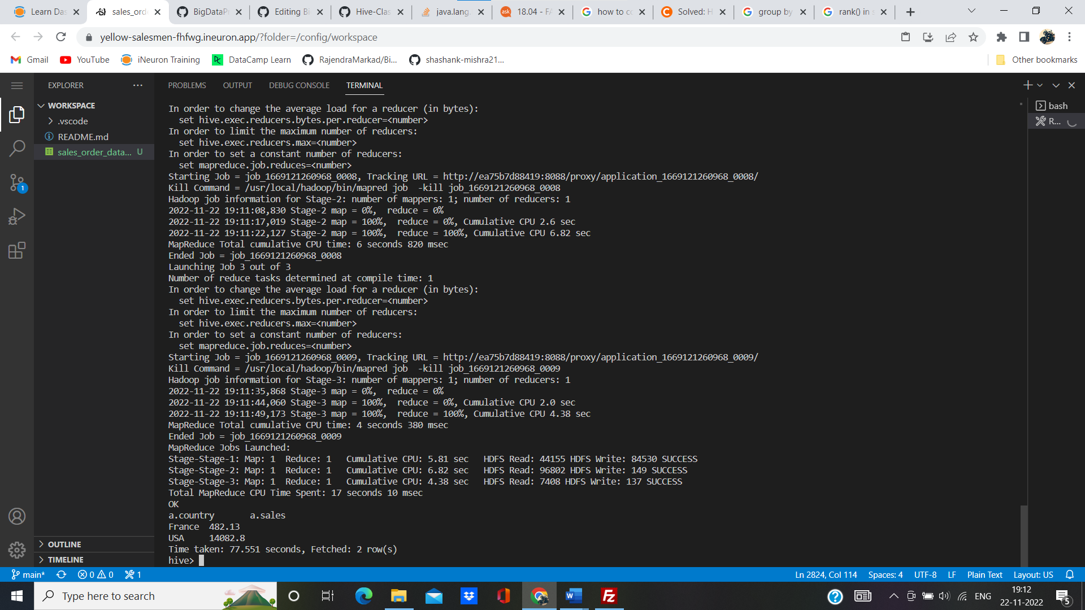

f. Calculate quarterly sales for each city.

**Hive>select sum(sales) as Quaterly_sale, qtr_id, city from sales_order_orc group by qtr_id, city;**

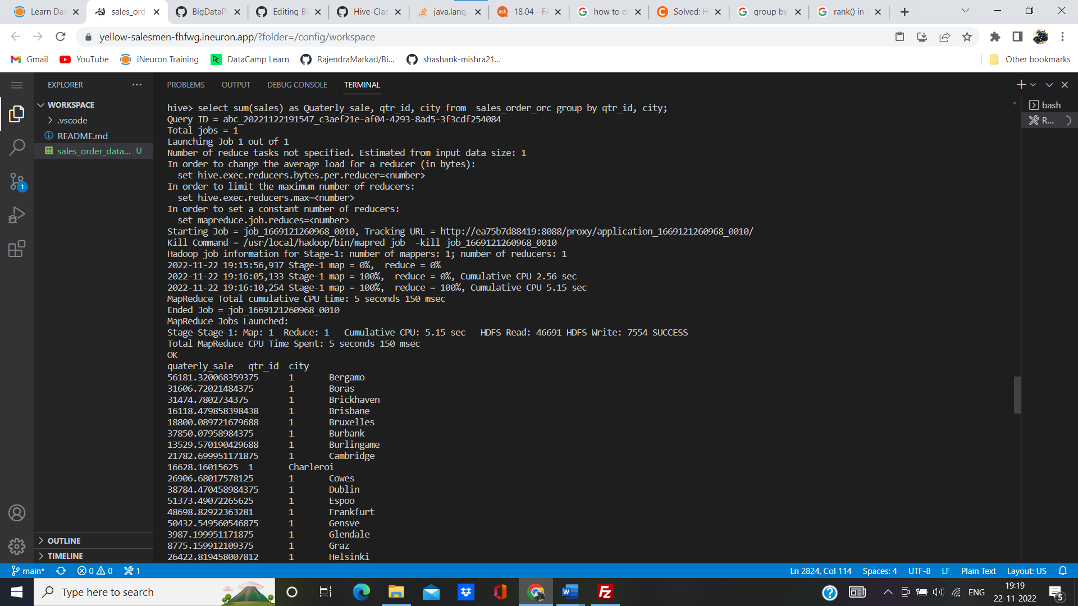 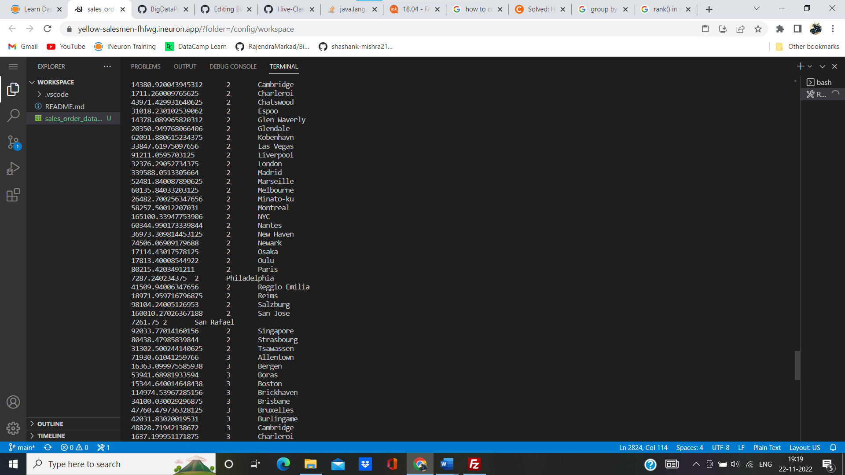 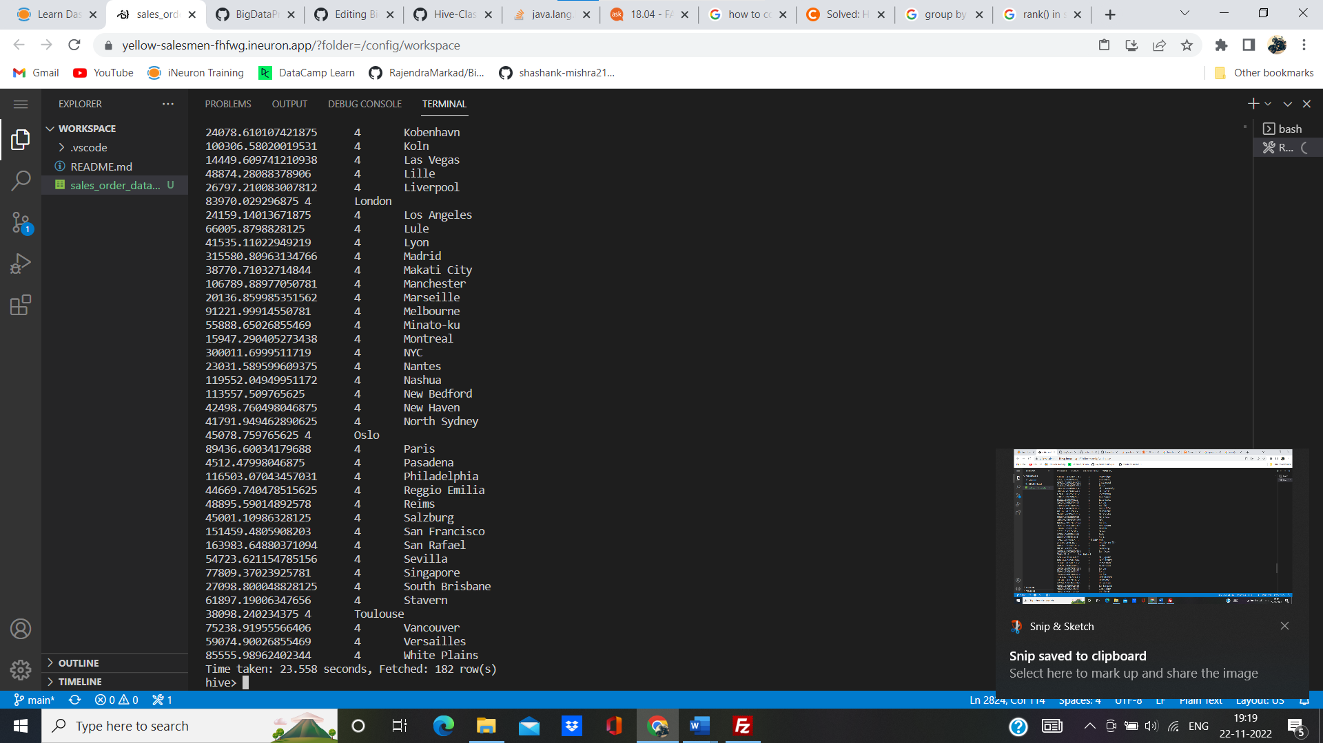

h. Find a month for each year in which maximum number of quantities were sold

**select month_id, year_id, quantityordered from (select month_id,year_id, quantityordered, dense_rank() over(partition by year_id order by quantityordered desc) as rnk from sales_order_csv)a where a.rnk =1;**

